Type A Uncertainty
# Source: AI Source: Provided by: [Data Path: Persons Table -> ID Column: 1, Name_En Column: Motasem Essam] -> From: [ChatGPT] on [7/17/2026]
Type A Uncertainty is a component of measurement uncertainty that is evaluated using statistical analysis of repeated measurements. It quantifies the variability observed when the same quantity is measured multiple times under the same conditions.
Type A uncertainty is based on experimental data rather than expert judgment or manufacturer specifications. It is widely used in metrology, scientific research, engineering, manufacturing, laboratory testing, and quality control.

Definition
# Source: AI Source: Provided by: [Data Path: Persons Table -> ID Column: 1, Name_En Column: Motasem Essam] -> From: [ChatGPT] on [7/17/2026]
Type A Uncertainty is measurement uncertainty evaluated by statistically analyzing a series of repeated observations of the same measurand.

Purpose
# Source: AI Source: Provided by: [Data Path: Persons Table -> ID Column: 1, Name_En Column: Motasem Essam] -> From: [ChatGPT] on [7/17/2026]
Type A uncertainty is used to:
- Quantify random variation in repeated measurements.
- Estimate measurement repeatability.
- Improve confidence in measurement results.
- Support uncertainty analysis.
- Provide a statistically justified uncertainty estimate.

Characteristics
# Source: AI Source: Provided by: [Data Path: Persons Table -> ID Column: 1, Name_En Column: Motasem Essam] -> From: [ChatGPT] on [7/17/2026]
Type A uncertainty:
- Is obtained from repeated measurements.
- Uses statistical methods.
- Primarily evaluates random errors.
- Depends on the number of observations.
- Usually decreases as the number of measurements increases.

Basis of Evaluation
# Source: AI Source: Provided by: [Data Path: Persons Table -> ID Column: 1, Name_En Column: Motasem Essam] -> From: [ChatGPT] on [7/17/2026]
Type A uncertainty is determined from experimental data by:
- Repeating the measurement several times.
- Calculating the arithmetic mean.
- Determining the standard deviation.
- Calculating the standard uncertainty of the mean.

Mathematical Procedure
# Source: AI Source: Provided by: [Data Path: Persons Table -> ID Column: 1, Name_En Column: Motasem Essam] -> From: [ChatGPT] on [7/17/2026]
Suppose n repeated measurements are made:
$$x_{1}, x_{2}, x_{3}, …, x_{n}$$

Step 1 – Calculate the Arithmetic Mean
# Source: AI Source: Provided by: [Data Path: Persons Table -> ID Column: 1, Name_En Column: Motasem Essam] -> From: [ChatGPT] on [7/17/2026]
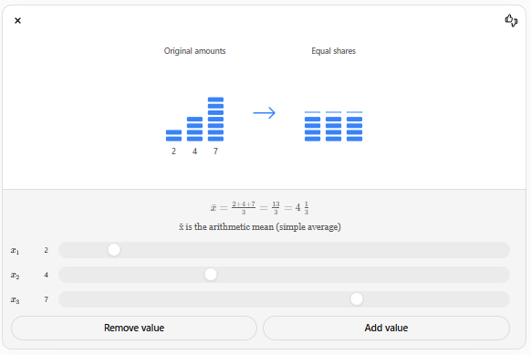
$$\boxed{\overset{ˉ}{x}=\frac{1}{n}\sum_{i=1}^{n}{x_{i}}}$$
where:
- $\overset{ˉ}{x}$= arithmetic mean
- $n$= number of measurements

Step 2 – Calculate the Sample Standard Deviation
# Source: AI Source: Provided by: [Data Path: Persons Table -> ID Column: 1, Name_En Column: Motasem Essam] -> From: [ChatGPT] on [7/17/2026]
$$\boxed{s=\sqrt{\frac{\sum_{i=1}^{n}{(}x_{i}-\overset{ˉ}{x})^{2}}{n-1}}}$$
where:
- $s$= sample standard deviation

Step 3 – Calculate the Standard Uncertainty (Type A)
# Source: AI Source: Provided by: [Data Path: Persons Table -> ID Column: 1, Name_En Column: Motasem Essam] -> From: [ChatGPT] on [7/17/2026]
$$\boxed{u_{A}=\frac{s}{\sqrt{n}}}$$
where:
- $u_{A}$= Type A standard uncertainty

Example
# Source: AI Source: Provided by: [Data Path: Persons Table -> ID Column: 1, Name_En Column: Motasem Essam] -> From: [ChatGPT] on [7/17/2026]
Repeated measurements of a rod length:
- 50.02 mm
- 50.01 mm
- 50.03 mm
- 50.00 mm
- 50.02 mm
Mean:
50.016 mm
Sample standard deviation:
0.011 mm
Number of measurements:
5
Type A uncertainty:
$$u_{A}=\frac{0.011}{\sqrt{5}}=0.0049\text{ mm}$$
Thus, the Type A standard uncertainty is approximately 0.005 mm.

Sources of Type A Uncertainty
# Source: AI Source: Provided by: [Data Path: Persons Table -> ID Column: 1, Name_En Column: Motasem Essam] -> From: [ChatGPT] on [7/17/2026]3
Type A uncertainty commonly results from:
- Random instrument fluctuations.
- Small environmental changes.
- Operator variability.
- Electronic noise.
- Natural process variation.
- Repeatability limitations.

Applications
# Source: AI Source: Provided by: [Data Path: Persons Table -> ID Column: 1, Name_En Column: Motasem Essam] -> From: [ChatGPT] on [7/17/2026]
Type A uncertainty is widely used in:
- Scientific laboratories.
- Engineering measurements.
- Manufacturing inspection.
- Calibration laboratories.
- Physics experiments.
- Chemistry.
- Medical laboratories.
- Quality assurance.
- Metrology institutes.

Advantages
# Source: AI Source: Provided by: [Data Path: Persons Table -> ID Column: 1, Name_En Column: Motasem Essam] -> From: [ChatGPT] on [7/17/2026]
Type A uncertainty:
- Is based on actual measurement data.
- Has strong statistical justification.
- Objectively represents random variability.
- Improves confidence in results.
- Is internationally recognized.

Disadvantages
# Source: AI Source: Provided by: [Data Path: Persons Table -> ID Column: 1, Name_En Column: Motasem Essam] -> From: [ChatGPT] on [7/17/2026]
- Requires repeated measurements.
- Can be time-consuming.
- Cannot estimate uncertainty from single measurements.
- Does not account for systematic effects by itself.

Type A Uncertainty vs. Type B Uncertainty
# Source: AI Source: Provided by: [Data Path: Persons Table -> ID Column: 1, Name_En Column: Motasem Essam] -> From: [ChatGPT] on [7/17/2026]
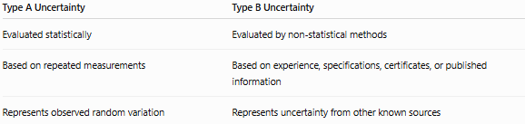
Type A Uncertainty | Type B Uncertainty
Evaluated statistically | Evaluated by non-statistical methods
Based on repeated measurements | Based on experience, specifications, certificates, or published information
Represents observed random variation | Represents uncertainty from other known sources

Type A Uncertainty vs. Random Error
# Source: AI Source: Provided by: [Data Path: Persons Table -> ID Column: 1, Name_En Column: Motasem Essam] -> From: [ChatGPT] on [7/17/2026]
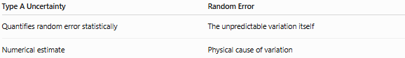
Type A Uncertainty | Random Error
Quantifies random error statistically | The unpredictable variation itself
Numerical estimate | Physical cause of variation

Importance
# Source: AI Source: Provided by: [Data Path: Persons Table -> ID Column: 1, Name_En Column: Motasem Essam] -> From: [ChatGPT] on [7/17/2026]
Type A uncertainty:
- Provides statistically valid uncertainty estimates.
- Improves measurement reliability.
- Supports international calibration standards.
- Enhances scientific credibility.
- Is an essential component of uncertainty budgets.

Common Mistakes
# Source: AI Source: Provided by: [Data Path: Persons Table -> ID Column: 1, Name_En Column: Motasem Essam] -> From: [ChatGPT] on [7/17/2026]
- Confusing Type A uncertainty with random error.
- Using too few repeated measurements.
- Ignoring outliers without justification.
- Using the population standard deviation instead of the sample standard deviation.
- Forgetting to divide by n\sqrt{n}n​ when calculating the standard uncertainty.

Key Points
# Source: AI Source: Provided by: [Data Path: Persons Table -> ID Column: 1, Name_En Column: Motasem Essam] -> From: [ChatGPT] on [7/17/2026]
- Type A uncertainty is evaluated using statistical analysis of repeated measurements.
- It is based on experimental observations, not assumptions.
- It primarily reflects random variability in the measurement process.
- The standard uncertainty is calculated as the sample standard deviation divided by the square root of the number of measurements.
- Type A uncertainty is widely used in metrology, science, engineering, and quality control.

Conclusion
# Source: AI Source: Provided by: [Data Path: Persons Table -> ID Column: 1, Name_En Column: Motasem Essam] -> From: [ChatGPT] on [7/17/2026]
Type A Uncertainty is a measurement uncertainty evaluated through the statistical analysis of repeated measurements of the same quantity. It provides an objective estimate of the random variability present in the measurement process by using the arithmetic mean, sample standard deviation, and standard uncertainty of the mean. Because it is derived directly from experimental data, Type A uncertainty offers a reliable and scientifically justified assessment of measurement repeatability. It plays a fundamental role in uncertainty analysis, calibration, scientific research, engineering, and quality assurance, where accurate and dependable measurement results are essential.

